Exercise 1 Look and write :
cow | donkey | goose | sheep | goat | horse

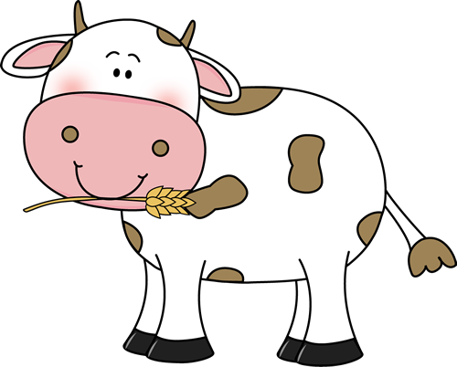 | 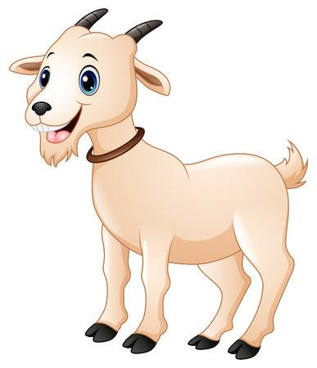 | 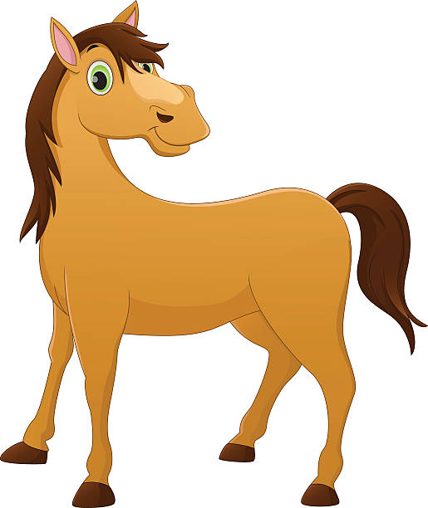
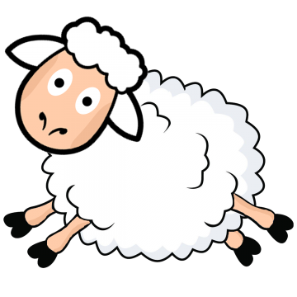 | 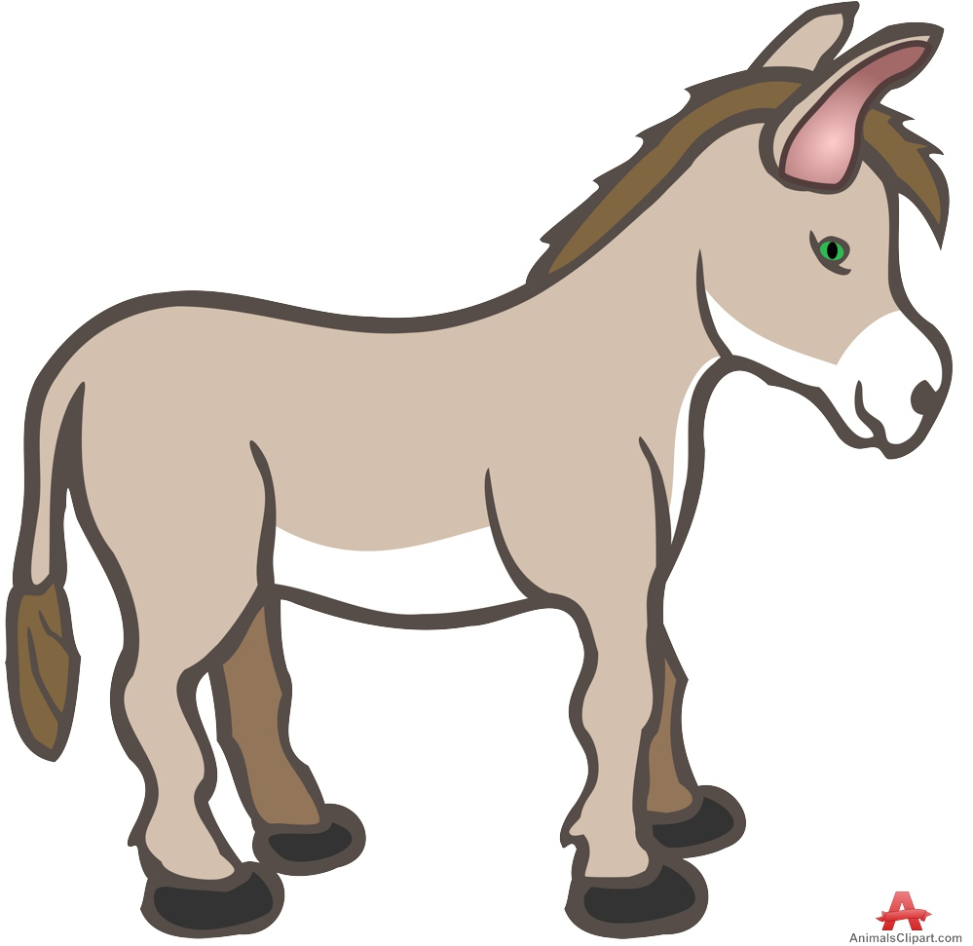 | 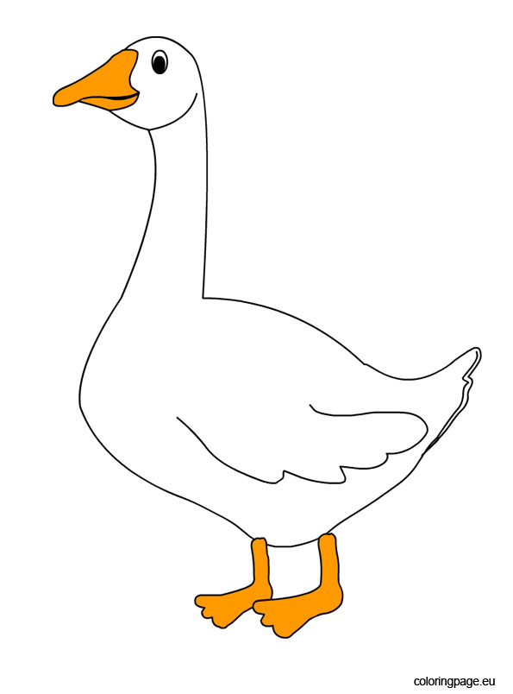
Exercise 2 Look and choose the correct words
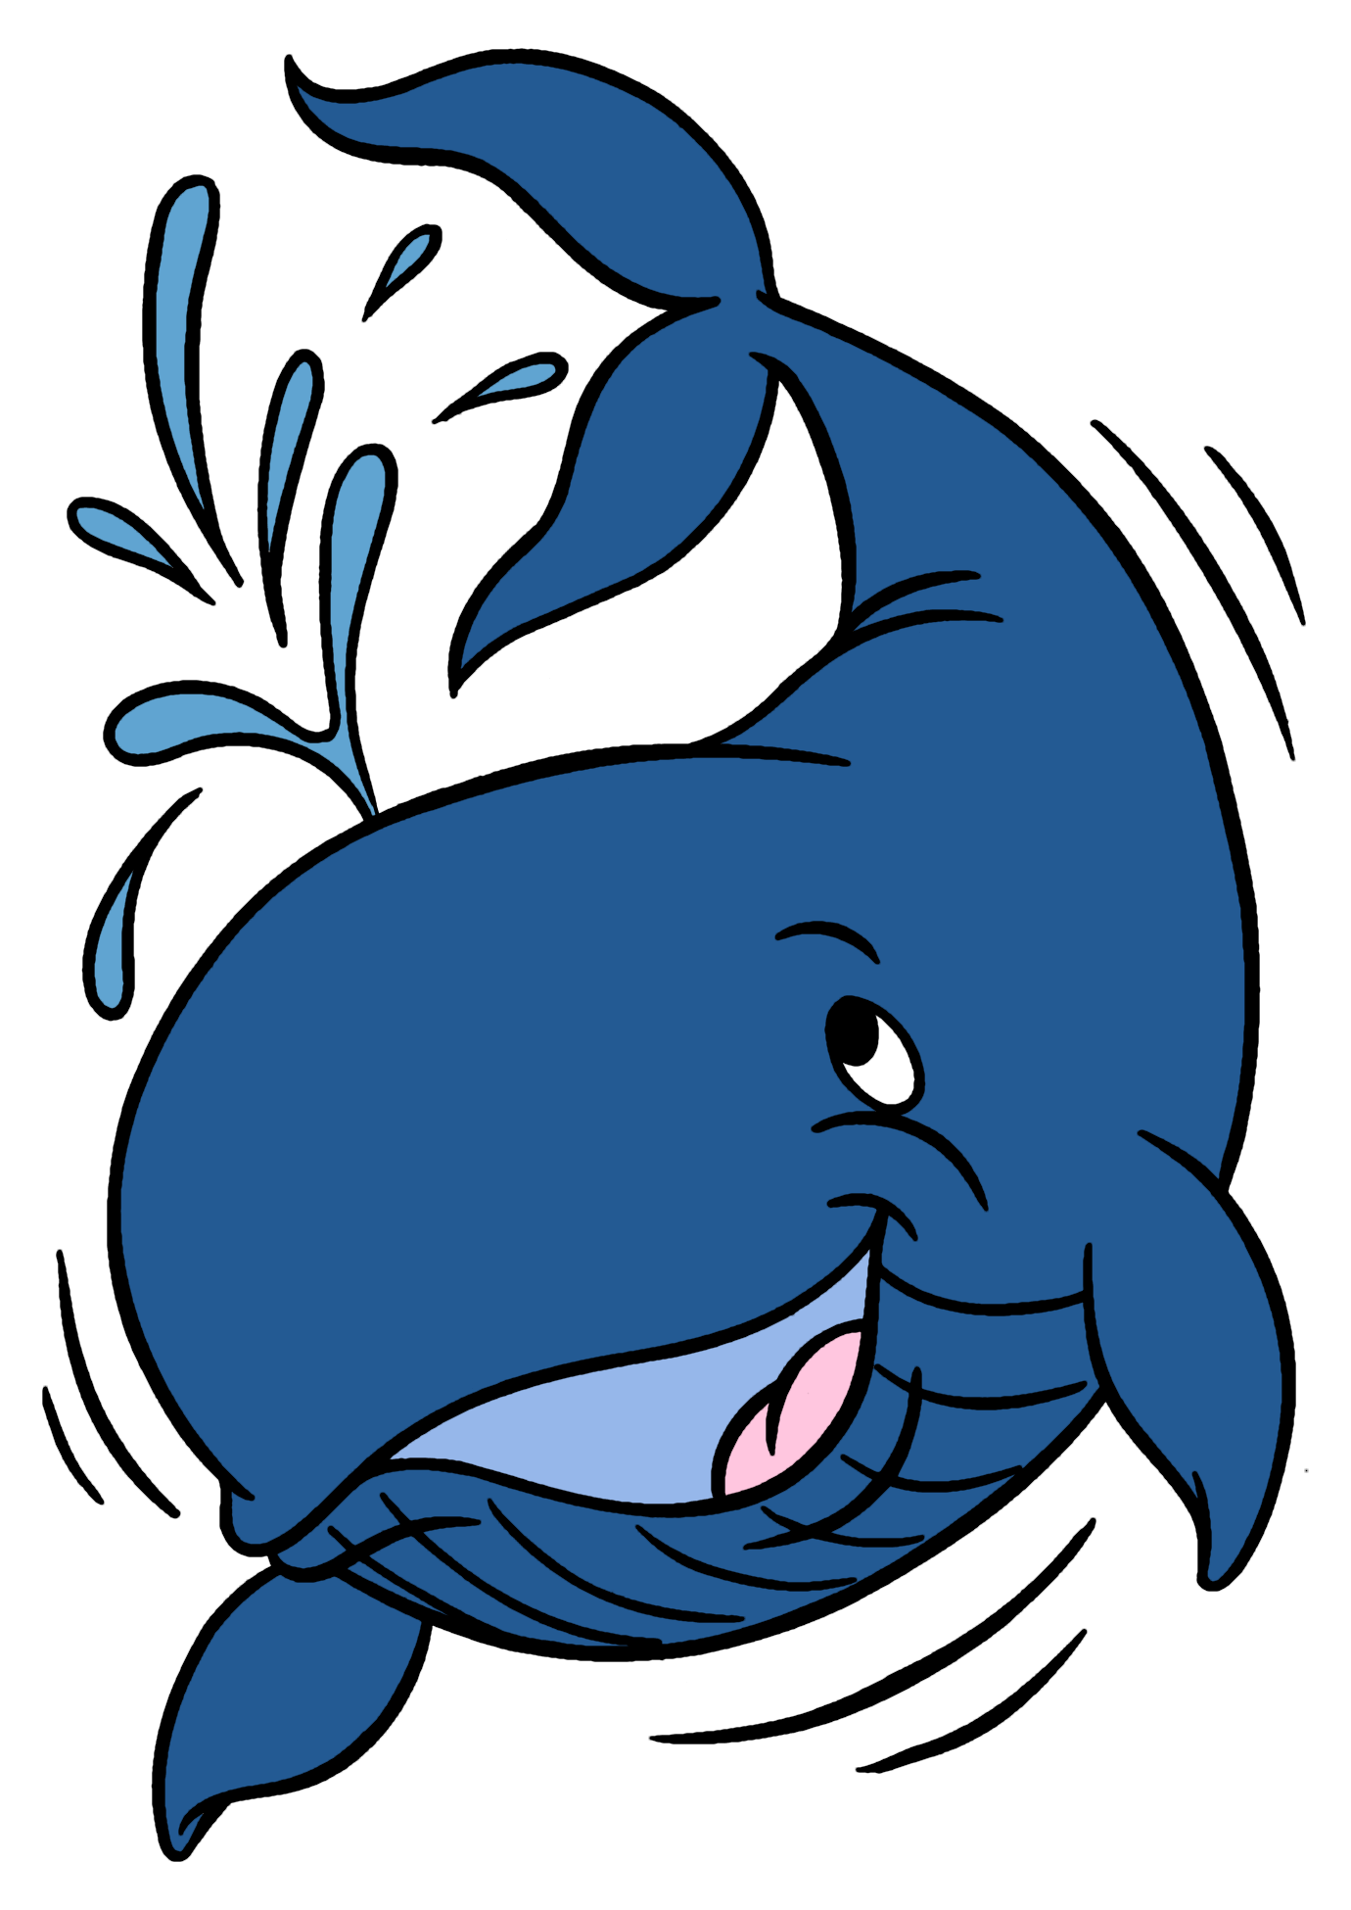 | 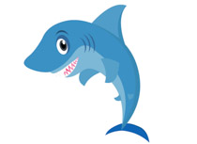 | bigger  a) The whale is / smaller than the shark
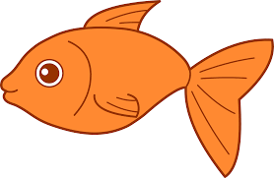 |  | b) The fish is bigger/ smaller than the shark.
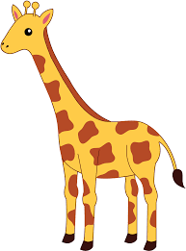 |  | c) The giraffe is shorter/ taller than the goat.
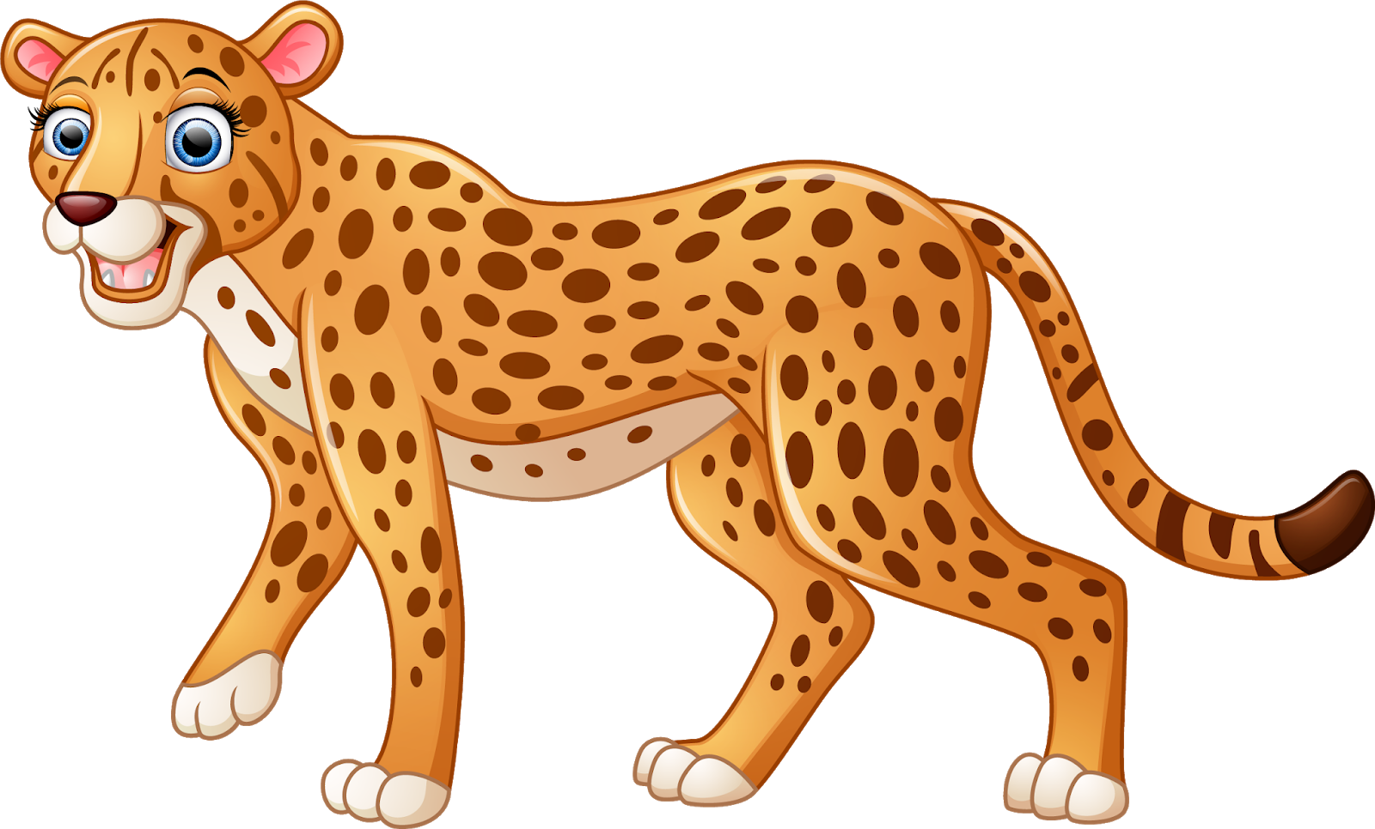 | 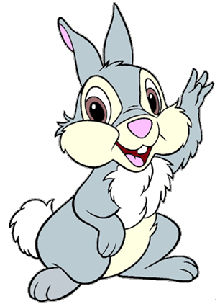 | d) The cheetah is faster/ slower than the rabbit.
 | 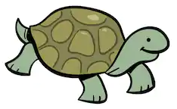 | e) The tortoise is faster/ slower than the rabbit.
 |  | f) The horse is faster/ slower than the sheep.
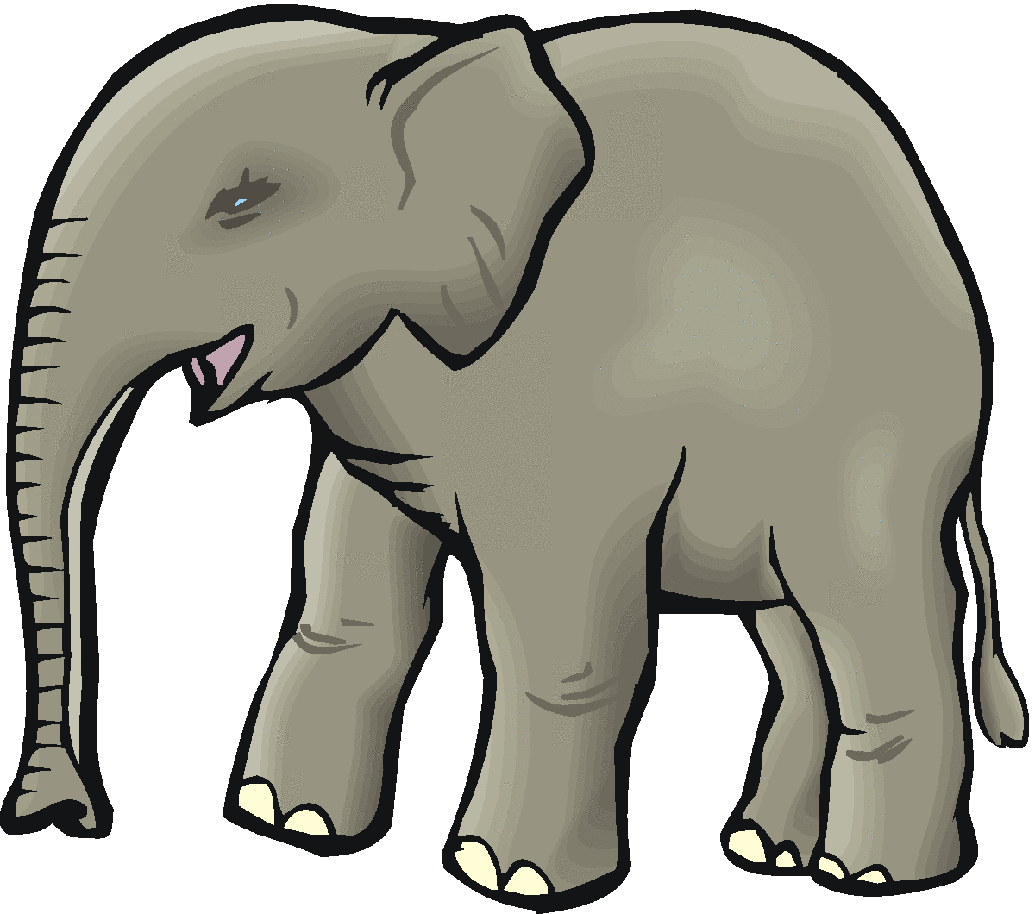 |  | g) The elephant is bigger / smaller than the goose.
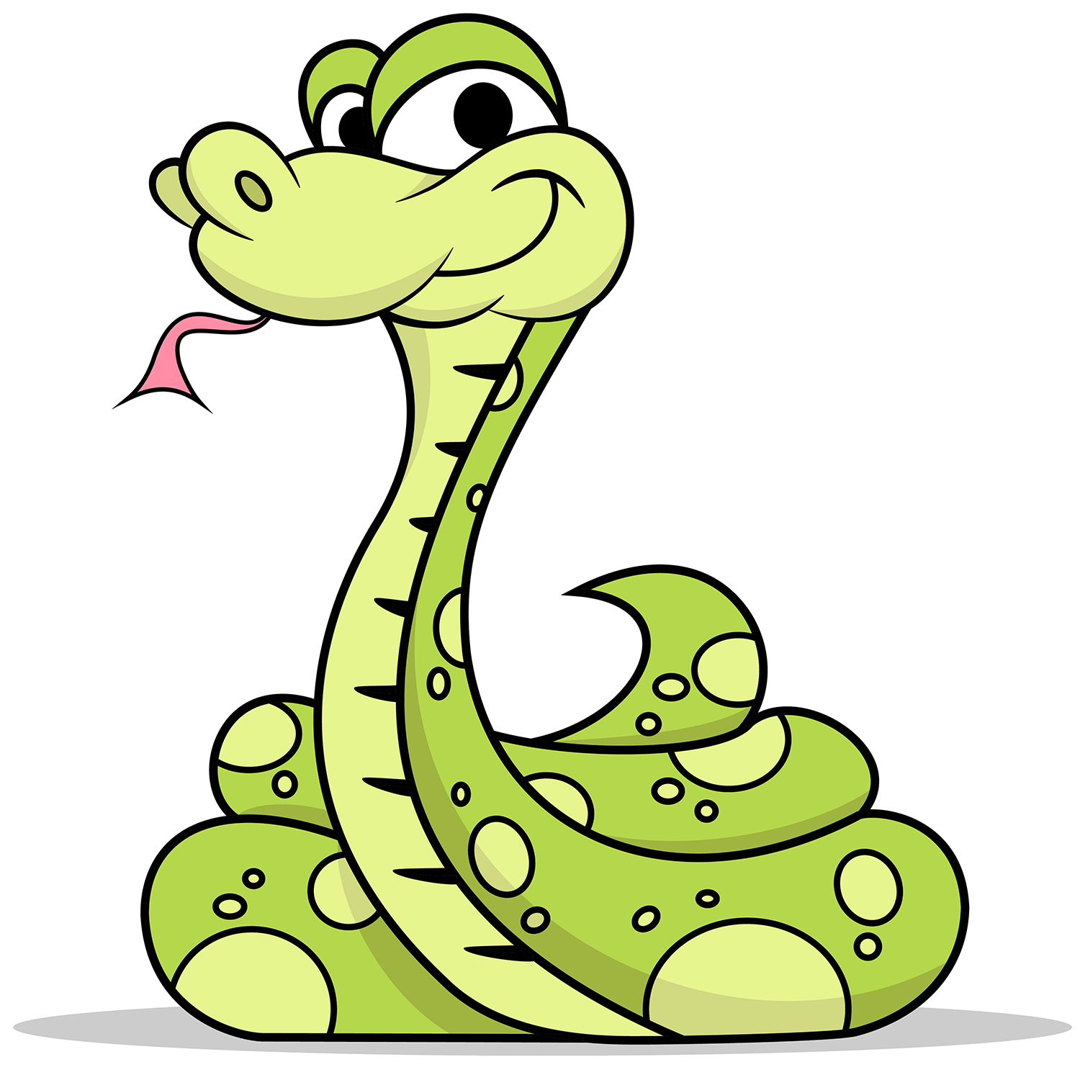 |  | h) The snake is longer /shorter than the fish.

Exercise 3 Compare the farm animal using the words from the box
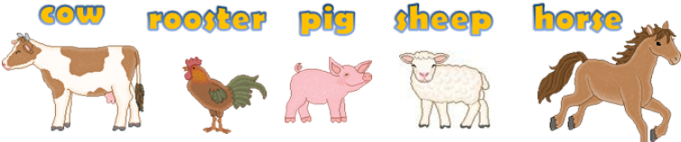
The cow is bigger than the rooster
- The pig is …………………(loud ) than the sheep.
- The horse is …………………( fast ) than the pig
- The sheep is …………………( small ) than the cow.
- The rooster is …………………(short ) than the horse.

Exercise 4 Order the words.
1) friend – taller – am – my – I
I am taller than my friend.
2) father – than – My – taller – me – is
…………………………………………………………………….
3) is – than – grandfather – me – older – My
…………………………………………………………………….
4) mouse – an – smaller – elephant – is – than – A
…………………………………………………………………….
5) the sheep – is – bigger – than – The cow
…………………………………………………………………….
6) The rubber – smaller – is – than – the pencil case
…………………………………………………………………….
7) the girl – taller – The woman – is – the
…………………………………………………………………….
8) smaller – The flower – is – the tree – than
…………………………………………………………………….
9 ) A giraffe – than – taller – is – a dog
…………………………………………………………………….
10) fatter – A horse – is – than – an elephant
…………………………………………………………………….
11) elephant – An – is – bigger – than – ant – an
…………………………………………………………………….
12) A pencil – shorter – is – than – a ruler
…………………………………………………………………….
13) A - bee - is – than - a – bear – bear
…………………………………………………………………….

